**Manually configure static IPs on the client devices (like Pc or your mobile phone) and verify connectivity using ping.**

**Manually Configuring IP on my PC:**

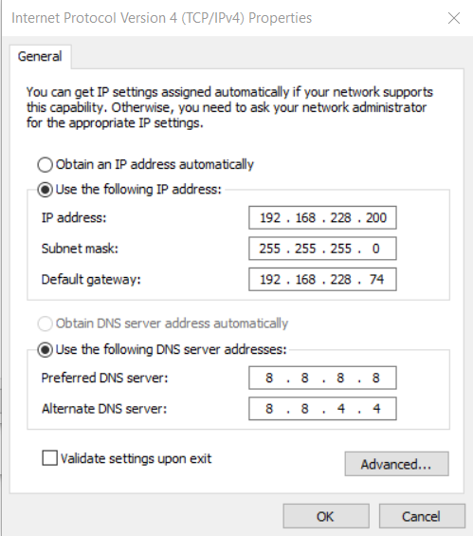

**Verifying the configuration:**

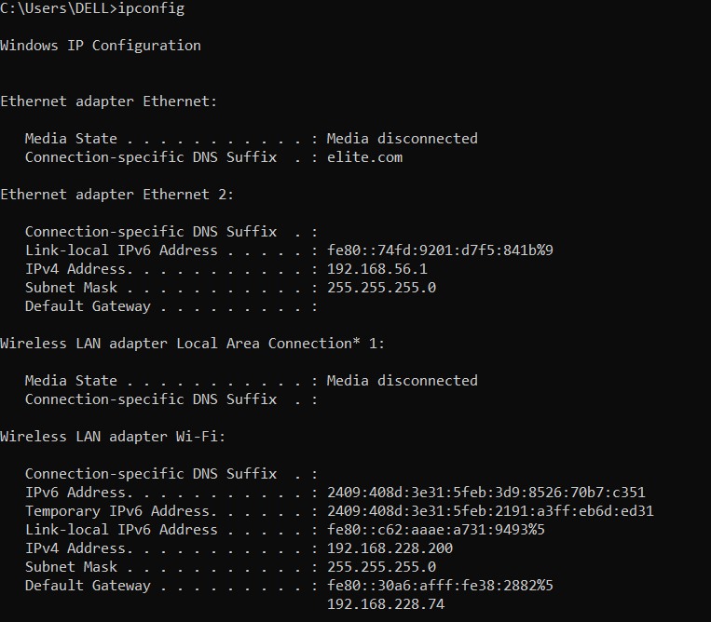

**Checking the Connectivity:**

**Pinging the default gateway**

**[Ping is successful]**

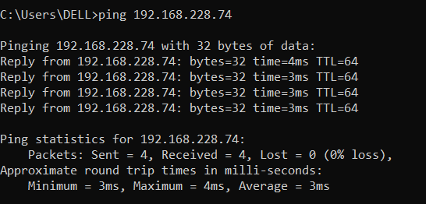

**Observation:**

A static IP address is manually assigned to a device, so it doesn’t change like a dynamic IP assigned by DHCP. By setting a static IP on my PC, I made sure that my device always has the same address in the network, which helps with easier communication and management.

After configuring the static IP, I checked the settings to confirm that the correct IP was assigned. Then, I tested the connection by pinging the default gateway. Since the ping was successful, it means my PC can communicate with the router, and there are no issues with the network setup or firewall blocking the connection.